**Centre Name: ACE-HCMC-2-FPT.**

**Address: 590 Cach Mang Thang 8, District 3, Ho Chi Minh City, Viet Nam.**

**Karnel Travel**

**USER GUIDE**

|  |  |  |
| --- | --- | --- |
| **Supervisor:** | Mr. Le Tuan Xuyen | |
| **Semester:** | 3 | |
| **Batch No:** | T1.2110.E0 | |
| **Group No:** | 2 | |
| **Order:** | **Full name** | **Roll No.** |
| 1. | Nguyen Xuan Thanh | Student1345187 |
| 2. | Huynh Nhat Trung | Student1345349 |
| 3. | Pham Gia Hung | Student1345178 |
| 4. | Duong Khai Cuong | Student1341576 |
| 5. | Nguyen Minh Hoang | Student1345179 |

* **This is to certify that**

**Mr.** Nguyen Xuan Thanh

**Mr.** Huynh Nhat Trung

**Mr.** Pham Gia Hung

**Mr.** Duong Khai Cuong

**Mr.** Nguyen Minh Hoang

**have successfully designed & developed:**

eProject: Karnel Travel

* **Submitted by:**

Mr. Le Tuan Xuyen

**Date of issue:** 16/06/2022

**Authorized Signature:**

1. Home Page

* 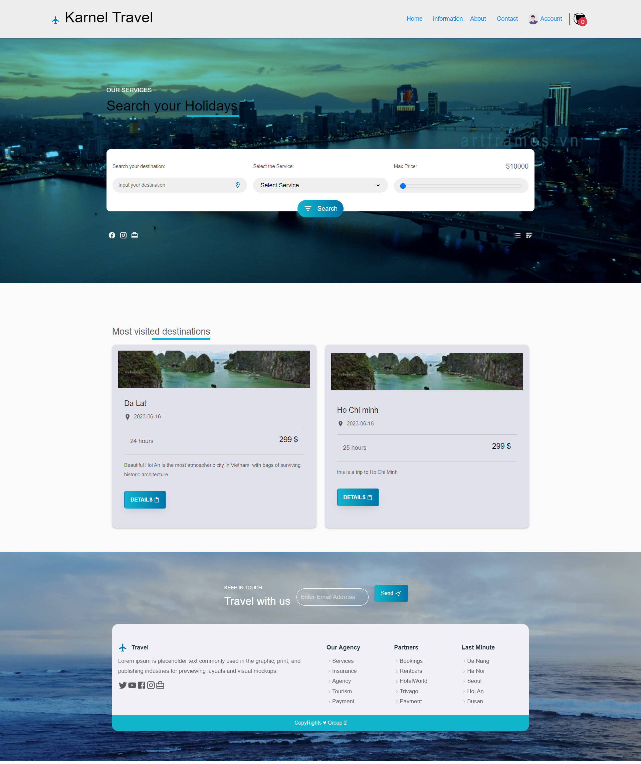User can enter website without having to login or register

1. 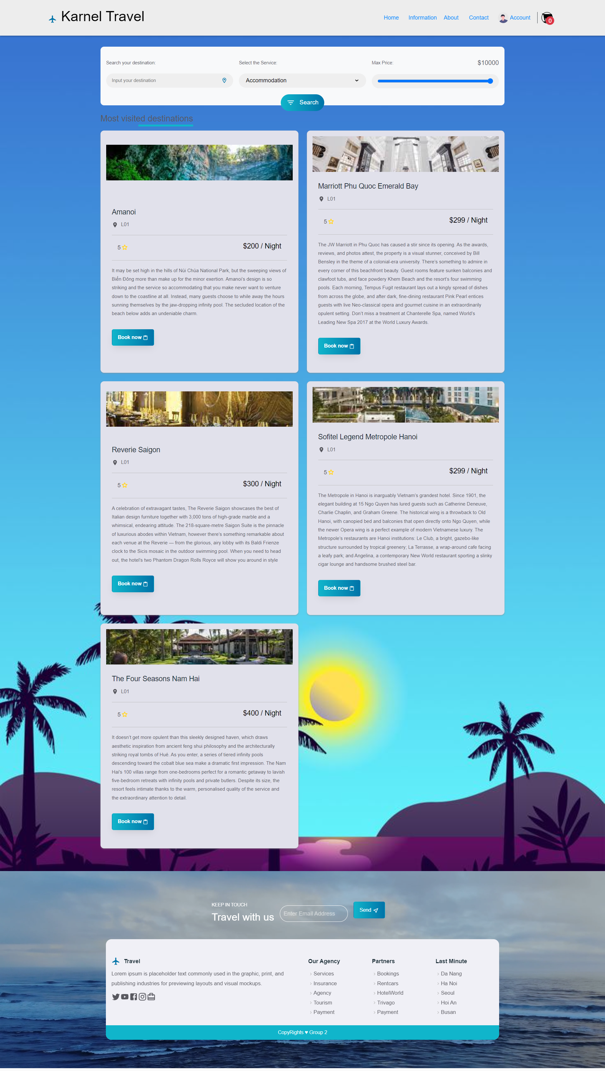Accommodation Page

* When clicking the “book now”, the chosen accommodation will move to the cart, so that user can confirm for booking that.
* When clicking to the image or the name of an accommodation, it will navigate to the detail page which shows all the information of an accommodation.

1. 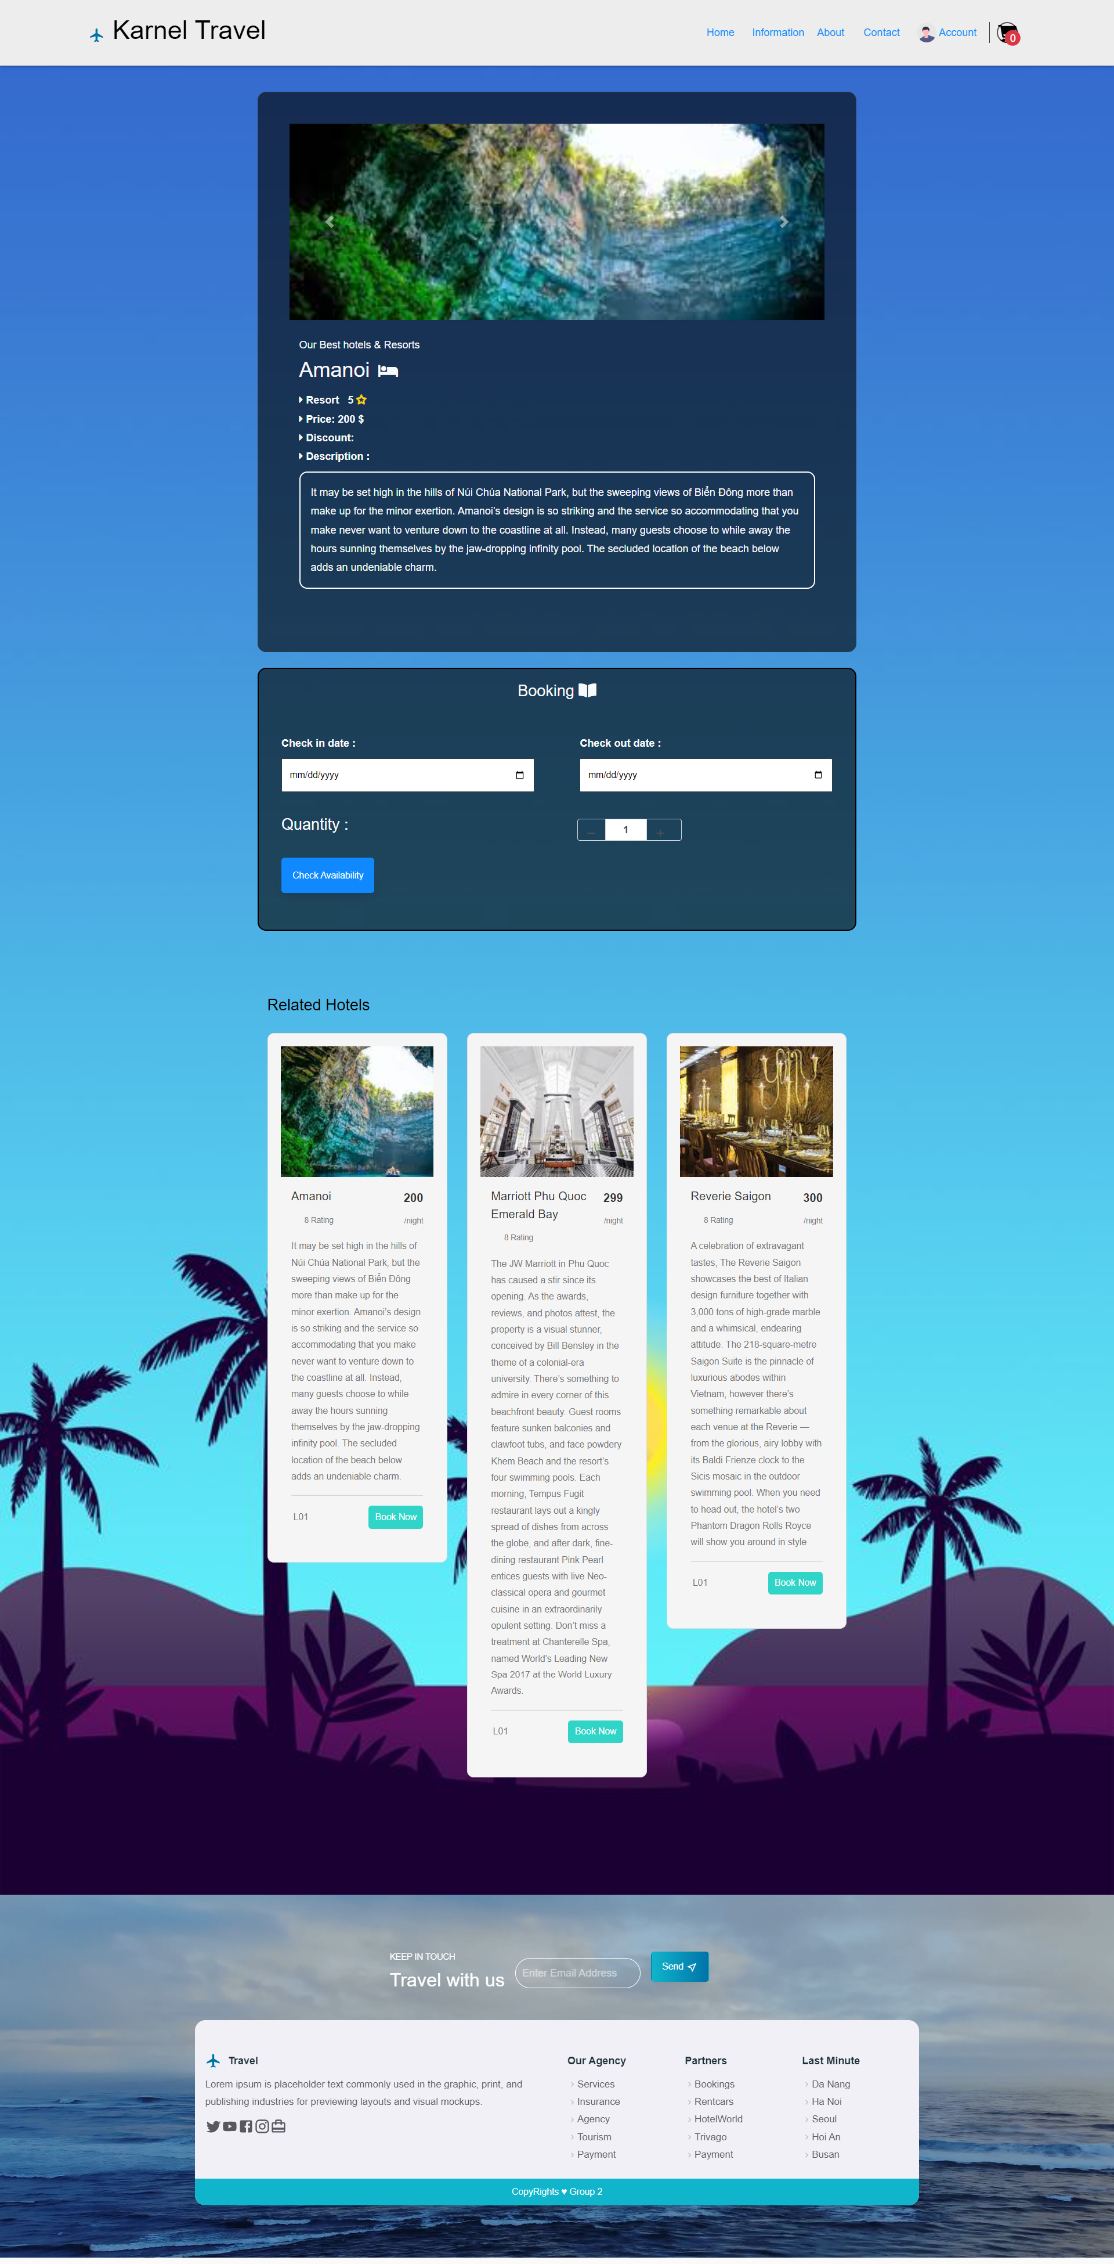Detail page

* This is a page that illustrates all the information about a product.
* Below the information of a product is a booking board. User can book a accommodation when they are in the detail page.
* Below the booking board is three extra product that is recommended.
* The others page, such as Restaurant, Tourist Spot, Transport, and Tours are the same as Accommodation

1. About Us

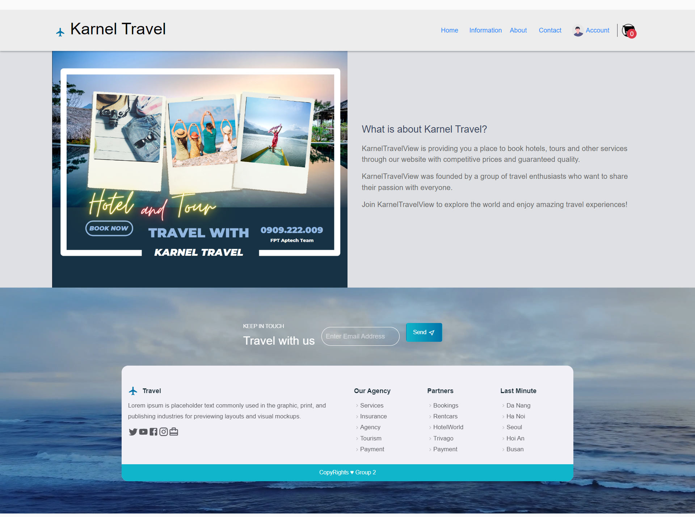This is a page that user can read the information about our website.

1. 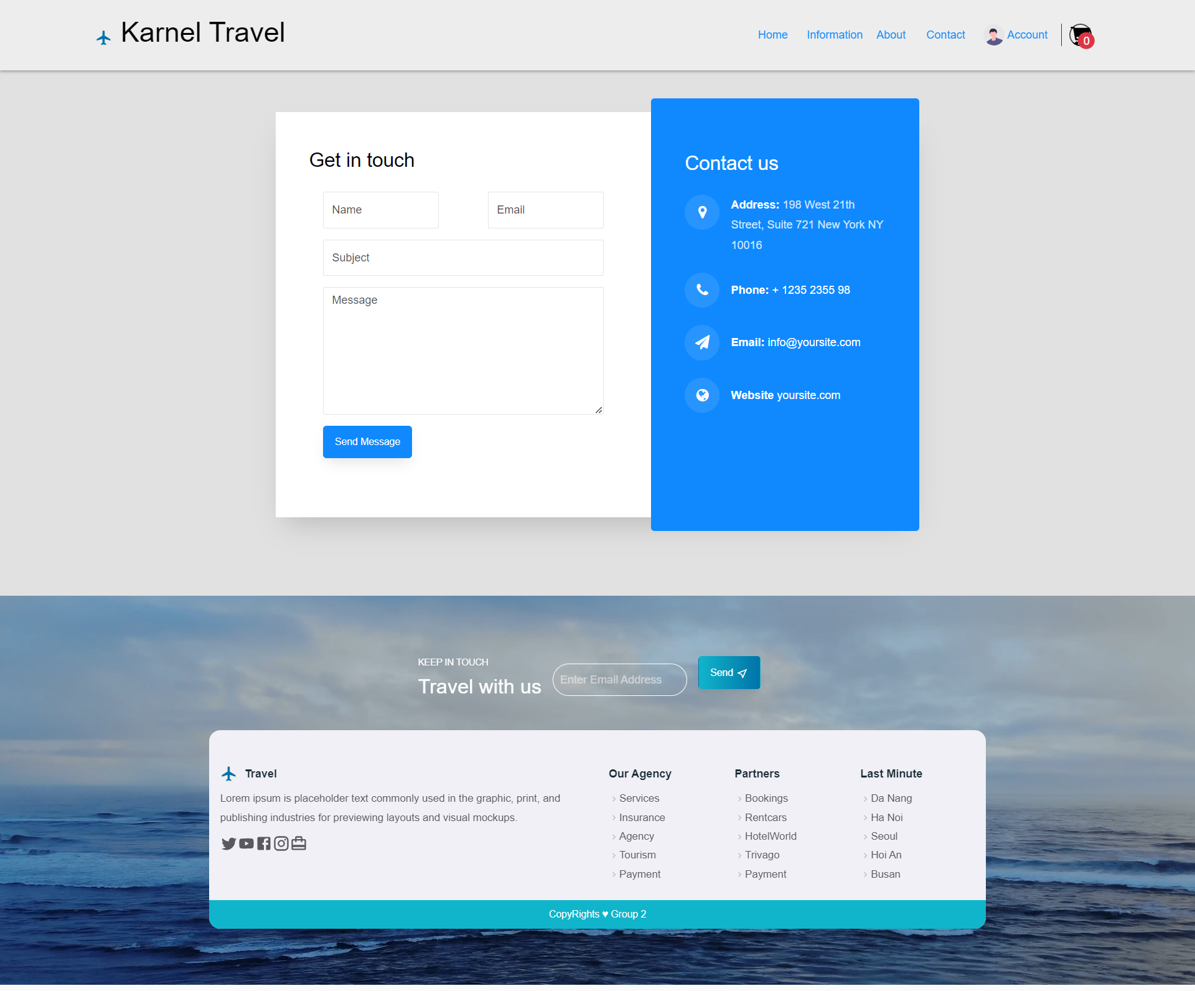Contact Us

Contact Us is a page that user can send any message for the web-owner with the hope that the better website in the future.

1. 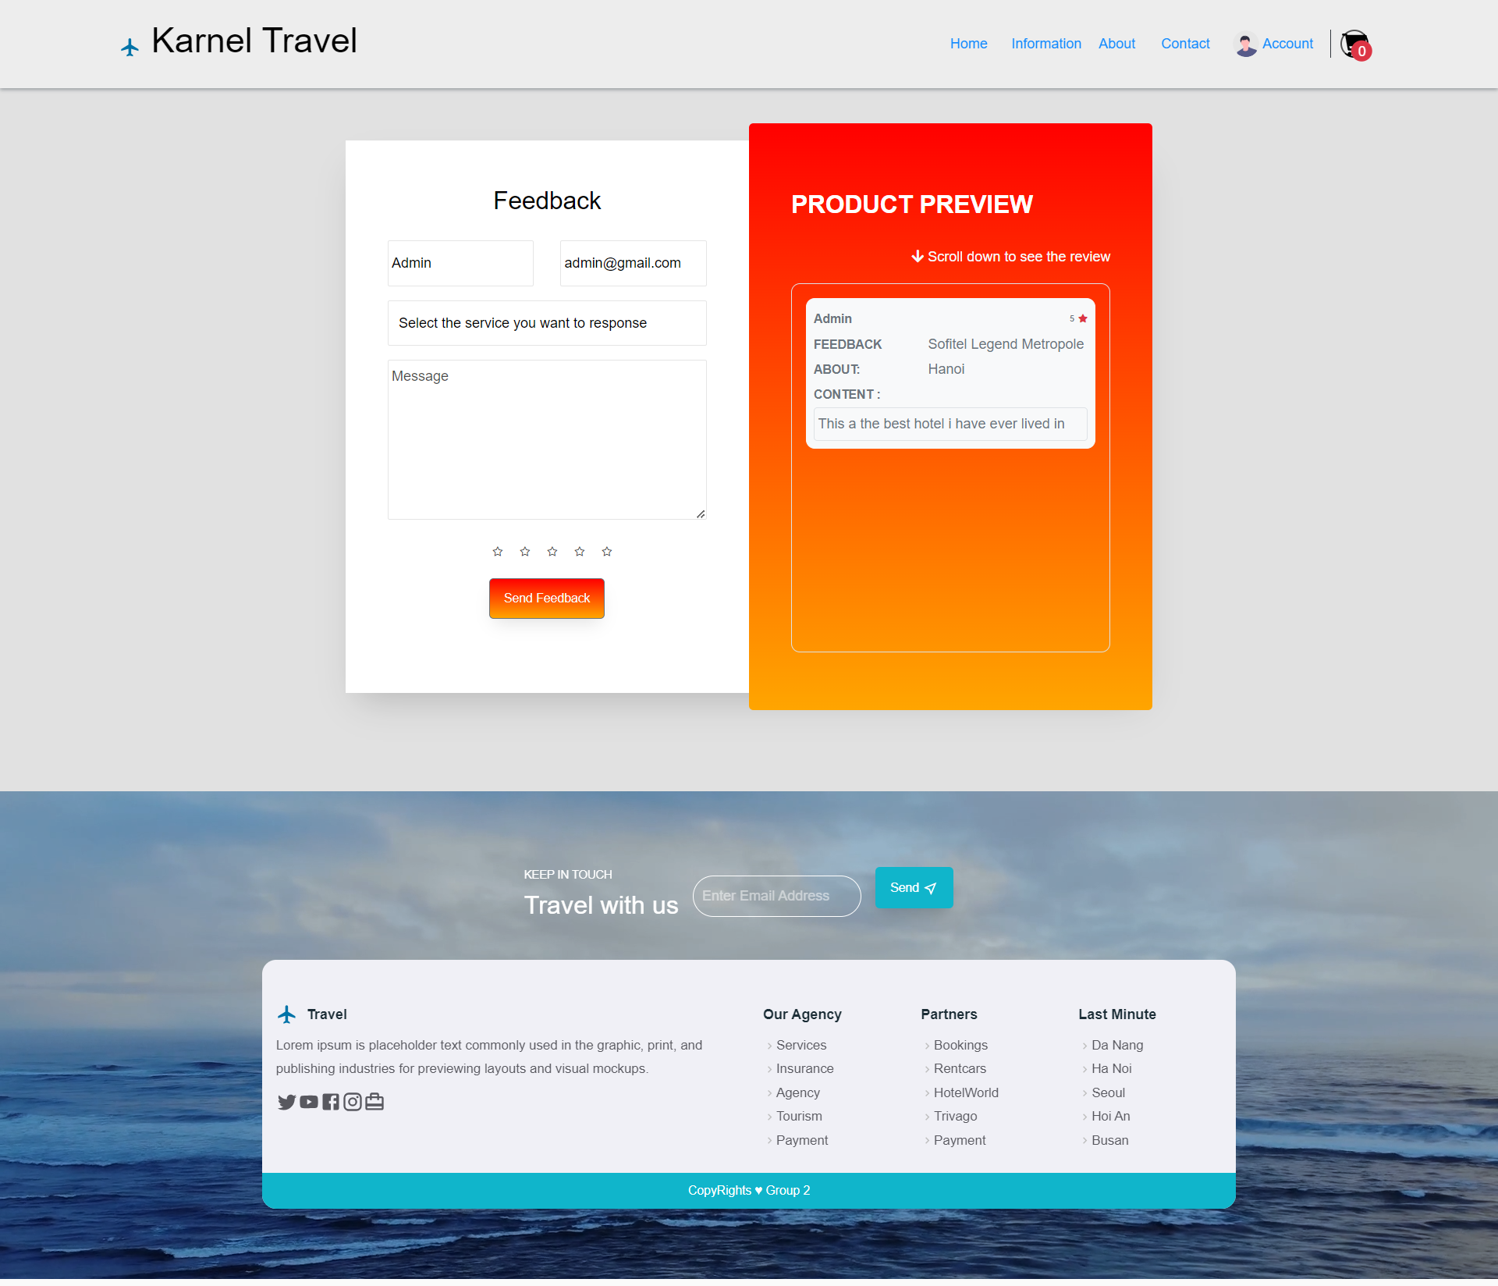Feedback

Feedback page is a place where user can leave their feedback to the tour or any accommodation, tourist Spot, restaurant that they joined.

1. 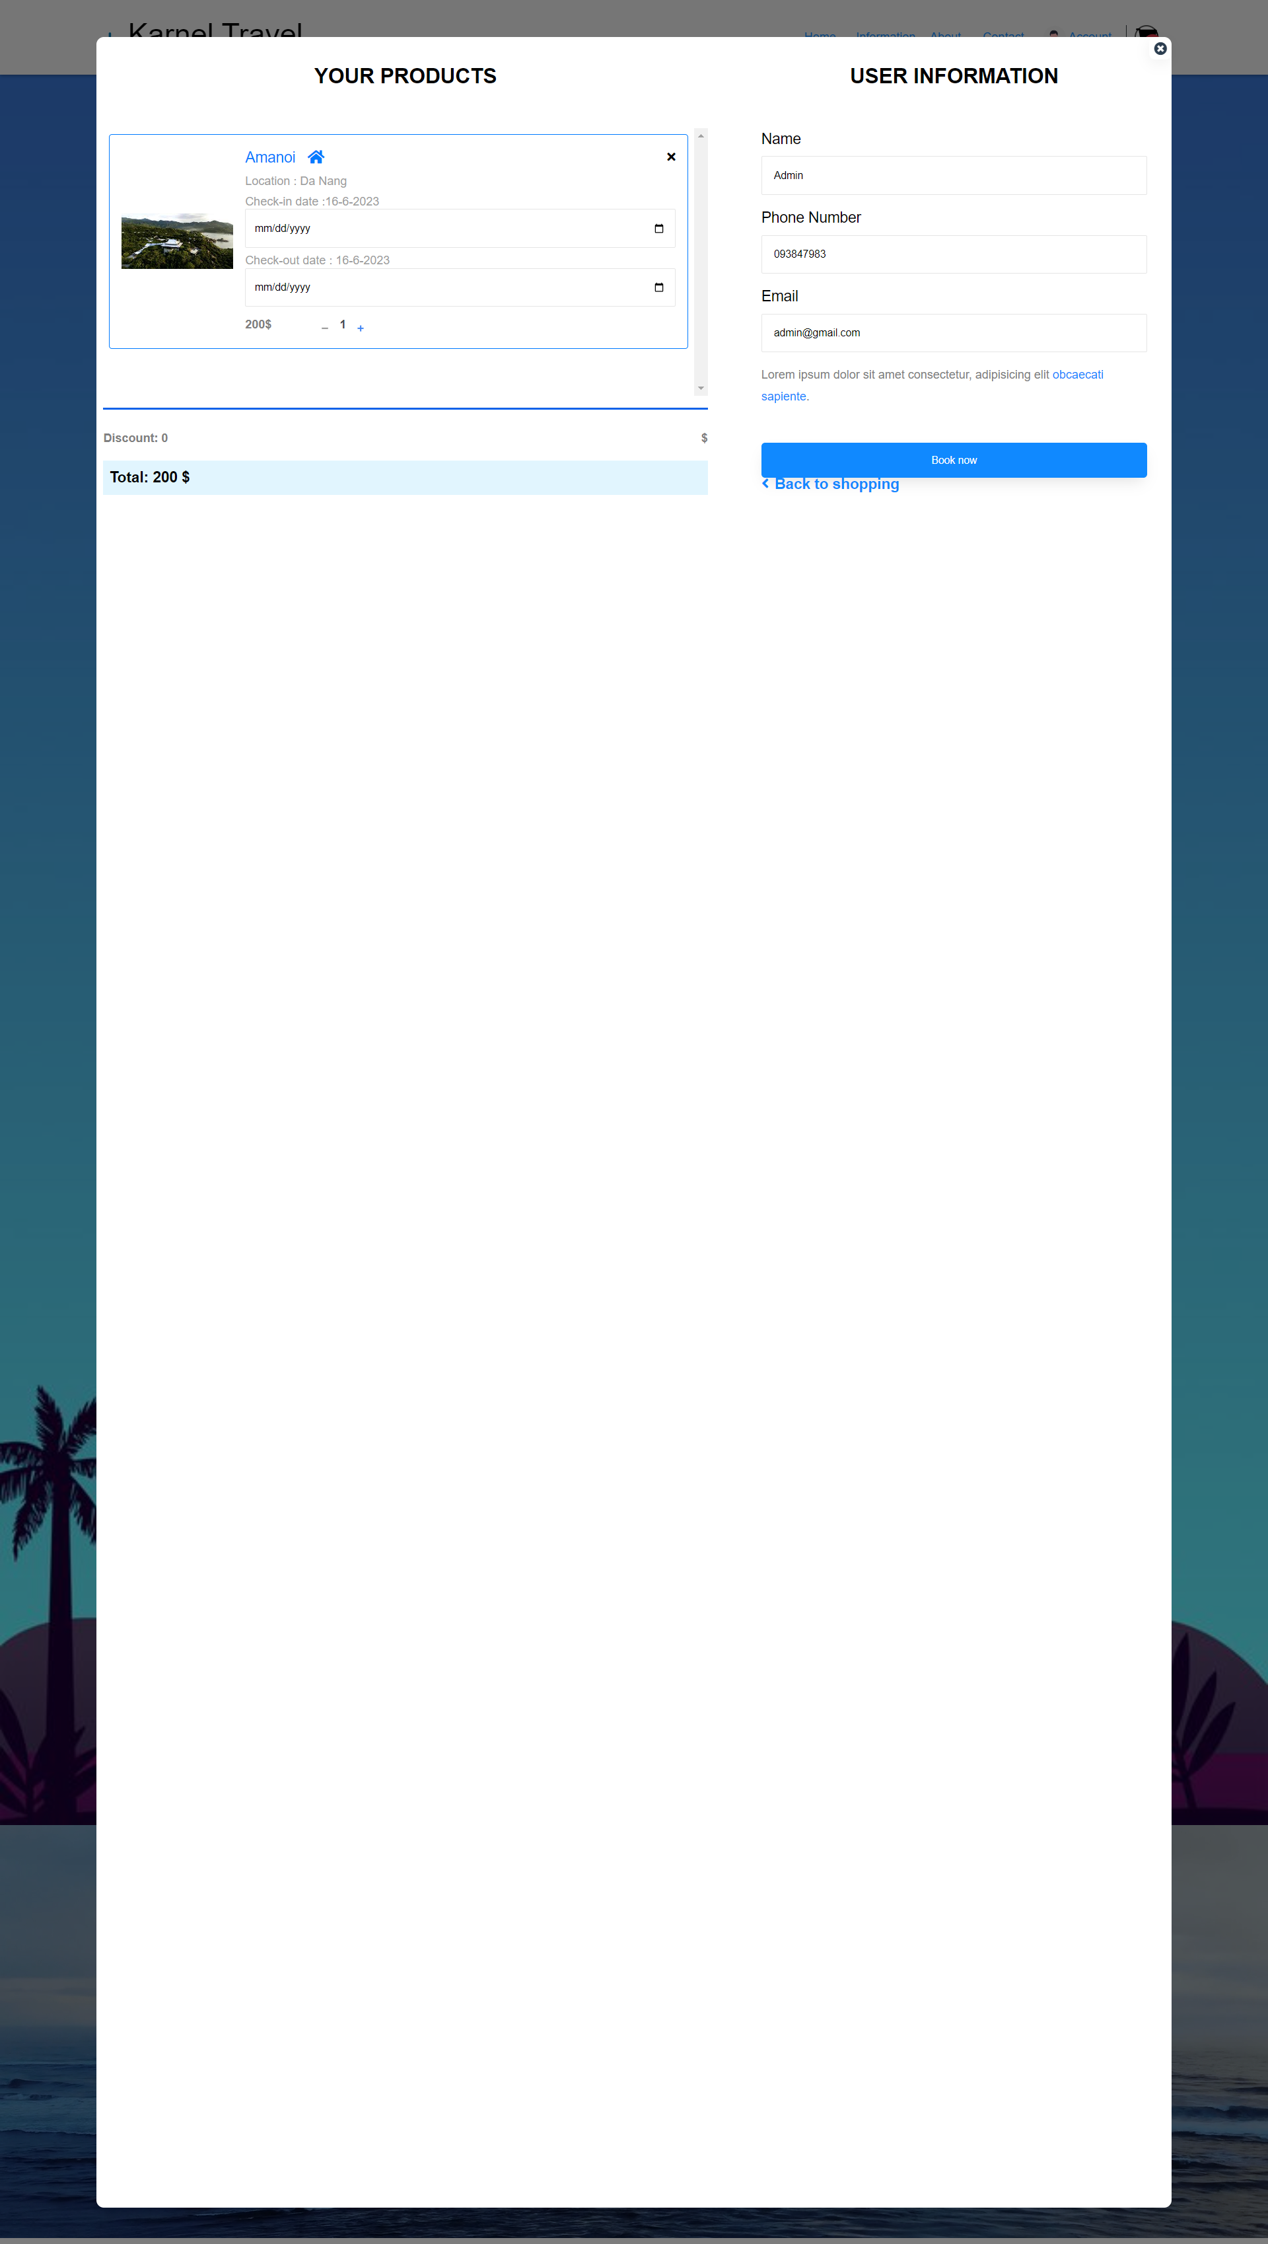Cart

Clicking to the cart icon will show up the cart which stores all the product that was booked by user. User can book all the product when clicking to the booking button.

* Please input your real email and check your mail

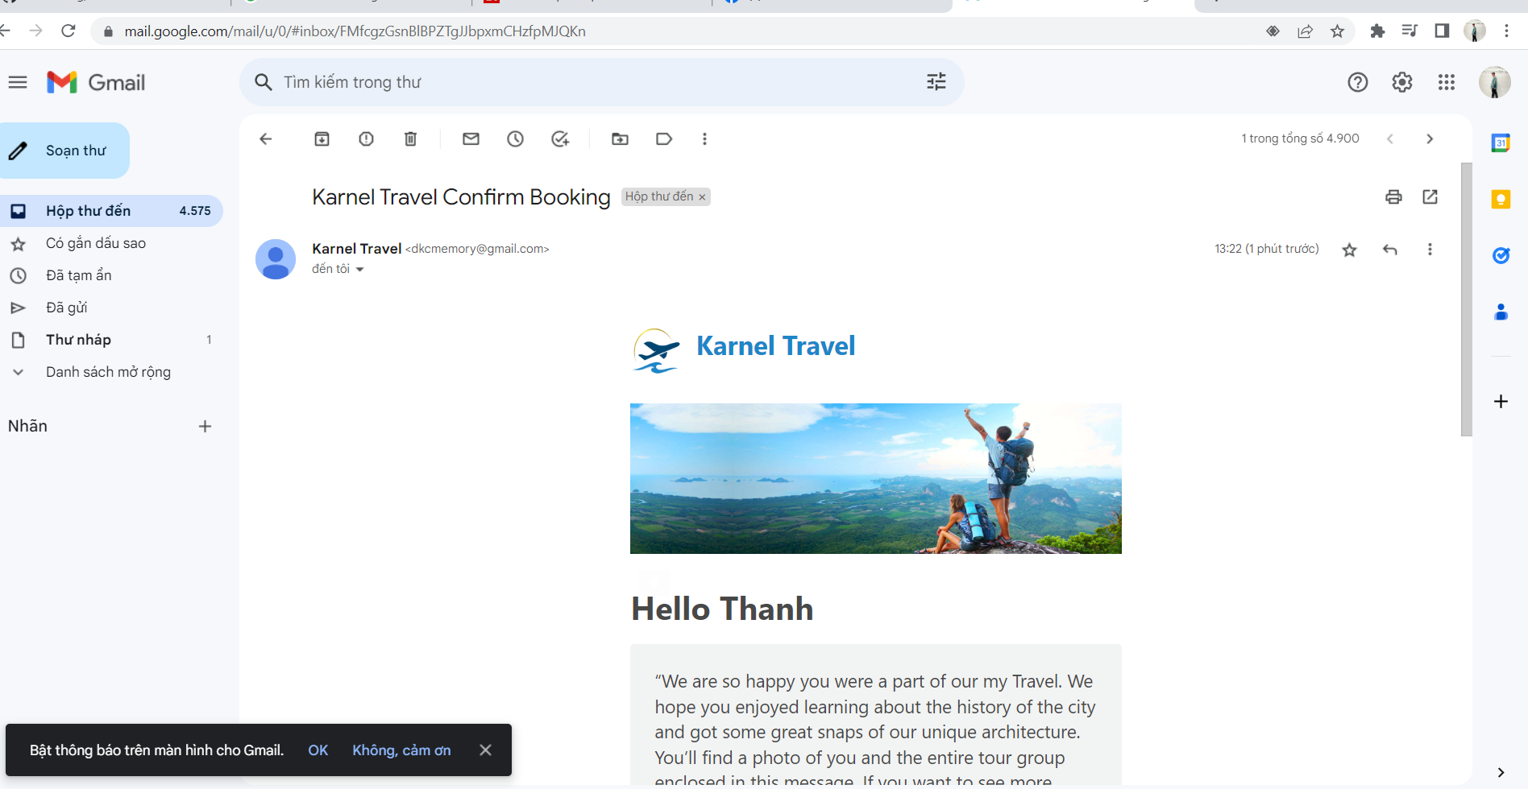

1. Login

However, please remember that users can only book a tour or any product in the website when they have already logged in to their account.

If users don’t have account, please click to the “Create an Account” bellow to start creating their own account.

Account:

Admin:

* Email: [admin@gmail.com](mailto:admin@gmail.com)
* Password: 123456

User:

* Email: [user@gmail.com](mailto:user@gmail.com)
* Password: 123456

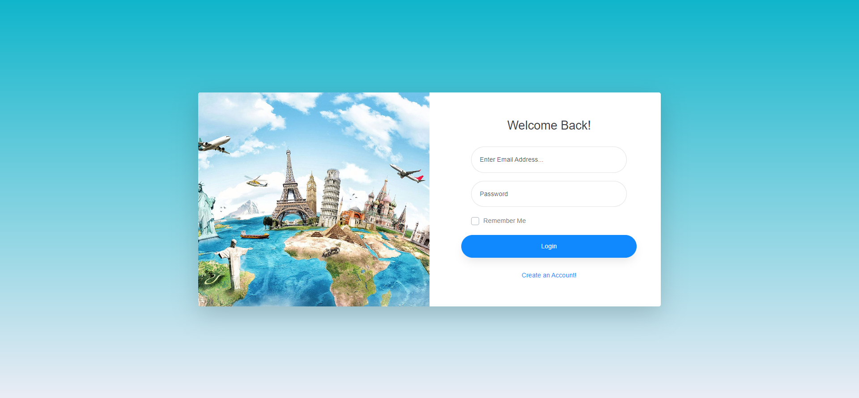

1. Register

* This is a register form that user can create their account.
* 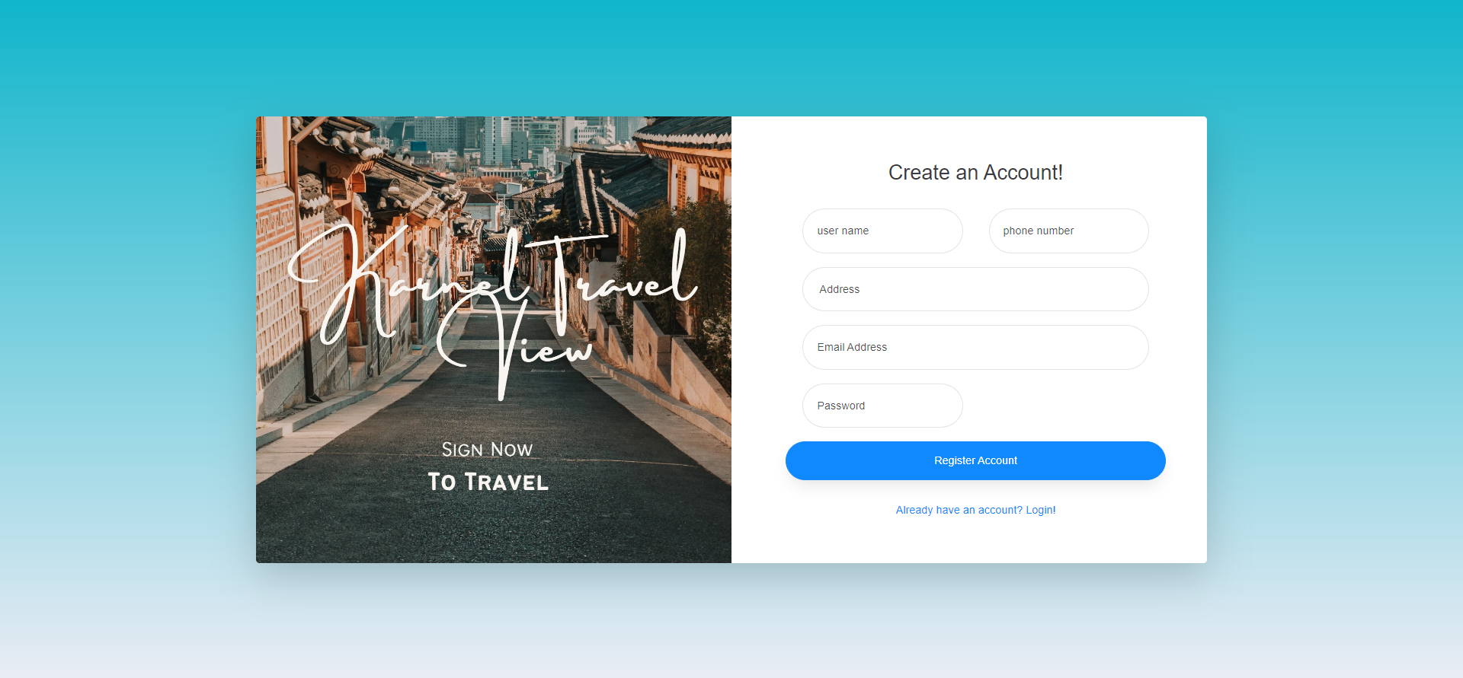You input real your email and check mail